Customizing the JUICE Dashboard

Contents

Overview 1

Removing modules from your program 3

Customizing modules by editing modules.txt 3

Adding modules by editing modules.txt 6

# Overview

The JUICE Dashboard includes 4 different views:

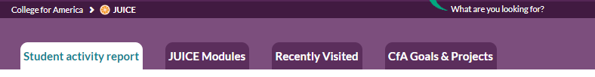

* **Student activity report** is available to users with the role of Coach or Educator. Additional roles can be specified in a JUICE config file. This view shows activity for a specific student specified in the launch to JUICE using the custom_studentId parameter.
* **JUICE Modules** shows the modules and mini-lessons that are available to the user in a specific JUICE program.
* **Recently Visited** shows the current user’s activity in the JUICE mini-lessons.
* **CfA Goals & Projects** shows the mapping between JUICE modules and course projects or assignments.

You can choose to hide some of these views OR customize their UI text by editing this file:

**/components/program-value/program-value-defaults.json**

This file is part of the site code, and is not stored in S3. See the document *Customizing basic UI components and creating alternate programs* for more information.

You can also customize the contents of the views by editing the file **modules.txt**. For core JUICE, this file is in the root of the S3 content bucket.

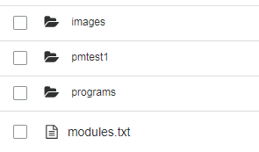

If you have created a custom program, the custom program will have its own copy of **modules.txt** in the root of the program’s directory:





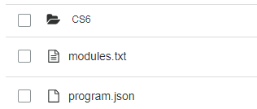

**modules.txt** defines the following:

* modules and mini-lessons that that are available in the program
* module and mini-lesson names
* Order in which they appear on the various dashboard views
* Competencies and subcompetencies associated with a module—used for data analysis only
* List of goals and projects / assignments that each module should be mapped to on the goals and project page.

IMPORTANT! Content-related changes made in **modules.txt** will only be reflected on the JUICE Dashboard.   
  
To make content changes to a JUICE module page, you must edit the appropriate **module.txt** file. To make content changes to a mini-lesson (modulette), you must edit the appropriate **modulette.txt** file.

For example, if you change the name of a mini-lesson on the Dashboard by editing **modules.txt**, the new name will appear on the Dashboard, but will not appear on the JUICE module page, or on the JUICE mini-lesson (modulette) page unless you also change the **module.txt** and **modulette.txt** files.

|  |  |
| --- | --- |
| **To change the content displayed here . . .** | **Edit this. . .** |
| JUICE Dashboard | modules.txt |
| JUICE module | module.txt |
| JUICE mini-lesson (modulette) | modulette.txt |
| JUICE mini-lesson Overview, Try it, or Games | Individual widget files |

You must also update the Mongo DB Search tables to reflect changes you make on the JUICE dashboard. See the document *Using tags to improve JUICE Search* for more information.

# Removing modules from your program

The file **modules.txt** contains a list of the modules included in the program, and each module’s attributes.

A module’s entry starts with the module title, and ends with the list of projects that the module supports.

To remove a module from your program, simply remove the module’s entry from **module.txt**.

# Customizing modules by editing modules.txt

To customize content on the Dashboard, edit the values found in **modules.txt**.

Some of the information contained in **modules.txt** is not used on the JUICE Dashboard. It is there because it is part of the module information from **module.txt**. These parameters are marked “Not used on Dashboard” in the table below. You can remove them or retain them. If you retain them, then you may want to keep them in sync with their values in module.txt.

The **modules.txt** parameters are as follows:

| **json parameter** | **Notes** |
| --- | --- |
| title | This is the title of the module as it will appear on the JUICE Dashboard.   If you change this, update it in module.txt also. |
| subtitle | Not used on Dashboard |
| description | Not used on Dashboard |
| id | This is the module id. It is usually formatted as  [id].[text name]  The [id] value must correspond to the directory name in S3.  The value after the “.” does not matter.  If the corresponding directory is not found, the module will be listed on the Dashboard, but clicking it will load an empty page. |
| goal | Deprecated |
| popup_title | Not used on Dashboard |
| popup_description | Not used on Dashboard |
| hide_from_dashboard | If this value is set to 1, the module will not appear on the Dashboard. |
| dashboard_order | This value controls the order in which the modules display in each of the Dashboard views. If two modules have the same number, the secondary sort is alphabetical by title. |
| competencies | This is optional. It’s a list of one or more skills that the module supports. It is stored with student activity data associated with the module. |
| competencies_id | This is optional. It’s a list of one or more IDs for the skills that the module supports. It is stored with student activity data associated with the module. |
| modulettes | This section of the json lists the modulettes (mini-lessons) that should be displayed with the module on the dashboard. Any changes to this section should be made in **module.tx**t and **modulette.txt** as needed. |
| name | This is the name of the modulette. It is in the form  [module id].[mini-lesson #].[text]  The [module id].[mini-lesson #] are considered to be the modulette id. These values should correspond to the modulette’s directories in S3. |
| title | This is the title that will display on the Dashboard. |
| id | This is the modulette’s id. It must be in the form  [module id].[mini-lesson #]  Where module id corresponds to the module directory name and mini-lesson # corresponds to the mini-lesson directory name in S3. |
| order | This value controls the order in which the modulettes display in each of the Dashboard views. If two modulettes have the same number, the secondary sort is alphabetical by title. |
| hide_from_dashboard | If this value is set to 1, the modulette will not appear on the Dashboard. |
| subcompetencies | This is optional. It’s a list of one or more subskills that the modulette supports. It is stored with student activity data associated with the modulette. |
| subcompetencies_id | This is optional. It’s a list of one or more IDs for the subskills that the modulette supports. It is stored with student activity data associated with the modulette. |
| projects | The information in this section is used to create entries on the Goals & Projects page. It is optional. |
| color | Deprecated |
| name | This is the name of the project that appears on the Dashboard |
| dashboard_order | This is the order in which the project is listed within its Goal. |
| goal | This is the name of the Goal that appears on the Dashboard |

Project name

Goal

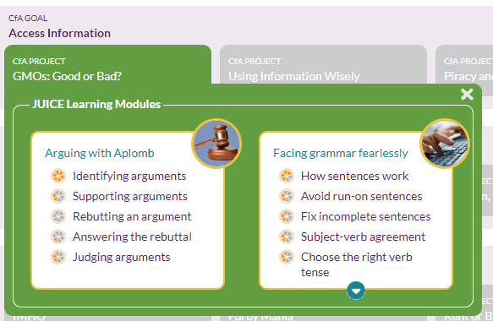

NOTE: The other text on the Goals & Projects page can be changed by editing

**/components/program-value/program-value-defaults.json**

This file is part of the site code, and is not stored in S3. See the document *Customizing basic UI components and creating alternate programs* for more information.

# Adding modules by editing modules.txt

To add a module, copy one of the existing module sections in the file, and then update it.

Add an S3 directory for the module using the same id as you have used in **modules.txt** and then continue to add content as describe in the rest of the documentation.